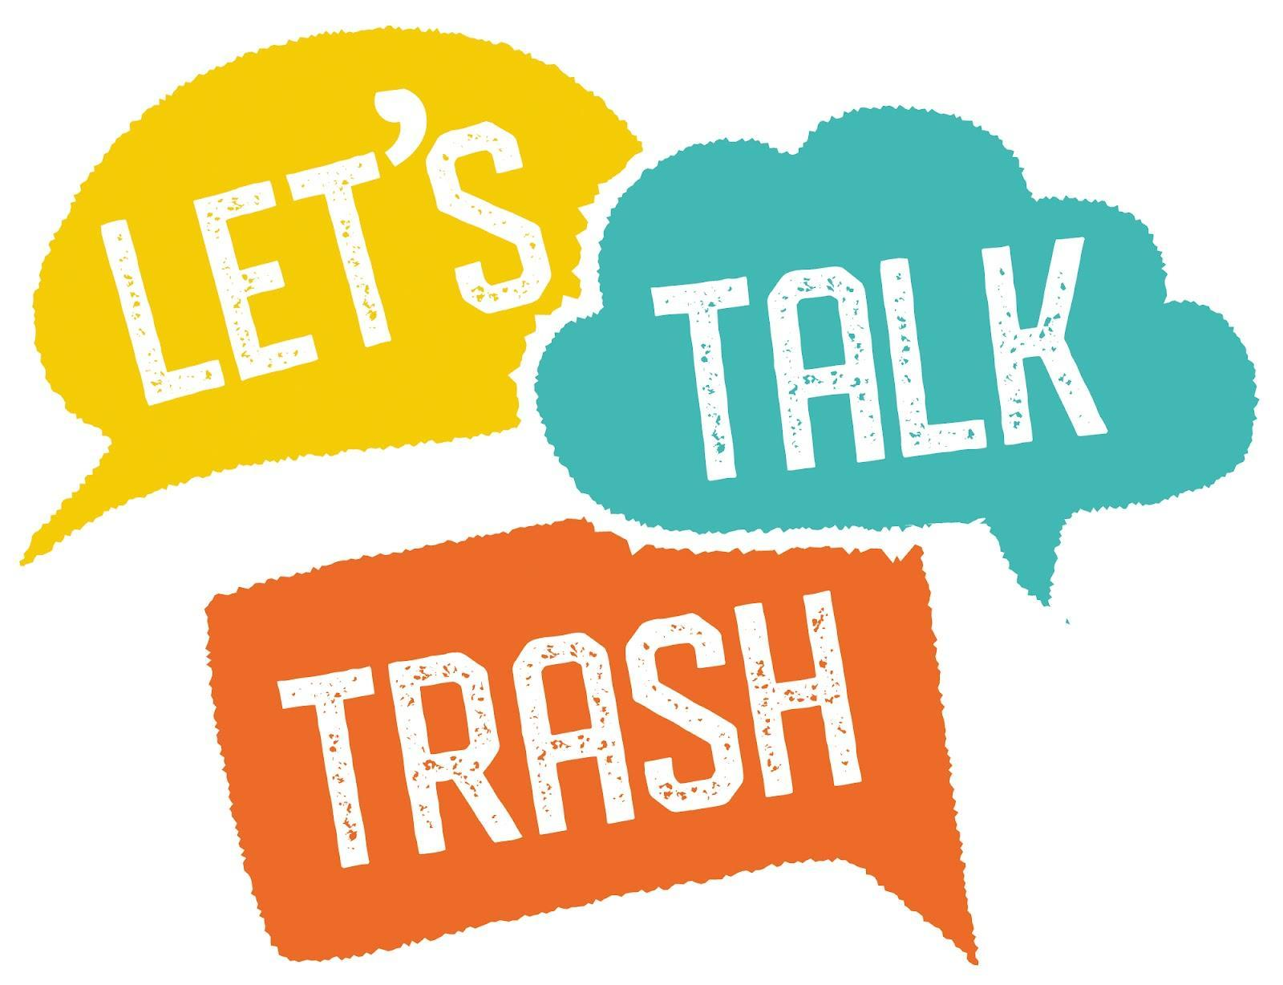
July, 2023

Braxted Park hosts 300 students at the trailblazing ‘Let’s Talk Trash’ festival in a bid to shift behavioural changes towards littering

In collaboration with Maldon District Council, Essex County Council and Plume Academy, Braxted Park Estate hosted the region’s first ‘Let’s Talk Trash’ Festival on Tuesday 18th July. Over 300 students aged 11-13 flocked to the grounds of the estate to take part in a number of exciting and engaging activities designed to shift behavioural change around littering, raise awareness of the environmental impacts and encourage the next generation to become changemakers.

Kicking off the day in the estate’s Pavilion, the students were introduced to the event with a short documentary-style film created for the festival by Mike Napier outlining the serious impacts of littering on our environment, as well as the community’s wellbeing. The video also featured powerful interviews with individuals from countries such as Japan, Dubai, Norway and Switzerland. Residents in these countries have completely different attitudes towards littering and believe it’s their responsibility to keep the environment clean. Braxted Park Estate owner and sustainability spokesperson Duncan Clark is hoping we can swiftly adopt the same mindset here in the UK and by working with local students hopes to challenge attitudes towards littering and create change across Essex.

Military RAF Veteran and guest speaker, Duncan Slater, who is passionate about making the world a better place delivered an inspiring talk to the youngsters. Slater spoke about his love of the great outdoors and how important it is as a community to come together and care for the ecosystems around us. His talk encouraged students to re-evaluate and reset their attitude towards littering and to stand up and do the right thing as opposed to going down the easy route that often leads to littering. Duncan hopes that following the event, students will also encourage their friends and family members to also protect the environment and drive the change.

Throughout the day, Plume Academy students took part in seven interactive zones where they enjoyed a quiz and bird feeder building with Essex Wildlife Trust, immersive theatre from Big Wheel Theatre Company and an array of hands-on activities including creating bug hotels and analysing the wildlife found in Braxted Park’s lakes.

As part of the day’s activities, students learnt about what happens to our litter when it does go in the bin and how Maldon is home to one of the most advanced AI-led recycling plants in the world. Big Green Recycling’s robots sort over 1,000 pieces of rubbish per minute and Braxted Park was delighted to host the robots at the event and invite students to participate in a Wheelie Bin Challenge for some memorable learning.

“The team and I were delighted to host such an important and motivating event at Braxted Park Estate, all made possible thanks to the ECC Climate Action Challenge Fund," said owner Duncan Clark. “I am greatly saddened by the littering around our Essex countryside and am delighted to do anything that helps educate young people to take the decisions required to reverse the trend. The festival was a huge success, and it was encouraging to see so many students leave feeling inspired to make a stand for the future of our region’s green spaces. We envision the ‘Let’s Talk Trash’ Festival as a recurring annual event
Key supporter of the event and attendee, Cllr Peter Schweir, Essex County Council’s Climate Czar and Cabinet Member for Environment, Waste Reduction and Recycling said, “It was a privilege to attend the ‘Let’s Talk Trash’ Festival and I really hope the event will shift the perceptions of the region’s youth and drive change for good. Working alongside our communities and schools is so important – we’ve all got to come together and make small changes bit by bit in order to make our county flourish.”

-ENDS-
For more information, press enquiries or interview opportunities, please contact Orange PR:
megan@orangepr.co.uk / amelia@orangepr.co.uk
01206 654320
Notes to Editor
< In collaboration with Maldon District Council, Essex County Council and Plume Academy, Braxted Park Estate hosted the region’s first ‘Let’s Talk Trash’ Festival last week on Tuesday 18th July.
< Over 300 students aged 11-13 flocked to the grounds of the estate to take part in a number of exciting and engaging activities designed to shift behavioural change around littering.
< Military RAF veteran Duncan Slater spoke about his love of the great outdoors and how important it is as a community to come together and care for the ecosystems around us.

- https://braxtedparkweddings.co.uk
- https://www.plume.essex.sch.uk/
- https://www.maldon.gov.uk/site/
- https://www.essex.gov.uk/

